https://www.gettysburg.edu/about/offices/provost/advancing_science/advancingscience.dot

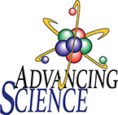 Advancing Science
Advancing Science provides equitable access to high quality science equipment and hands-on experiences at no cost to K-12 schools in south-central Pennsylvania. By partnering with K-12 teachers, Advancing Science provides engaging classroom activities that are matched to school district curricula and Pennsylvania learning standards. Additionally, teachers are supported through professional development opportunities.

