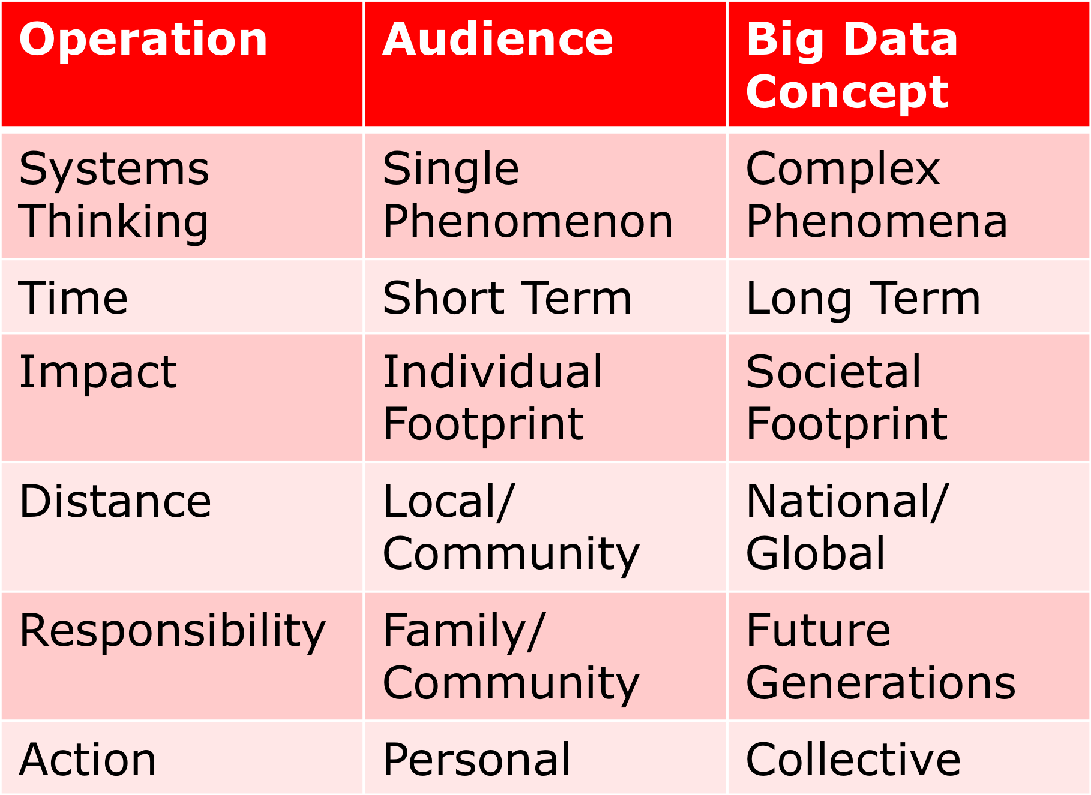
We started with these Sustainability Goals
Goal: to have visitors better understand their place in the large-scale statistical data that define sustainability.

We translated the Sustainability Goals into the Exhibition Dynamics

Things always need a second look
There’s more than one way to see things
Sometimes causes are hidden
Things that matter are not always in front of your face.
Either break these up or demonstrate both concepts in this section
Simple actions might have complicated/unexpected results.
Sometimes more isn’t always better

Time
Things are always changing
What’s a good idea now isn’t always a good idea later
A decision that works now, might have to change later

Impact - Individual and Societal
Little decisions make big changes (aggregate, long term, emergent, lots of concepts in this statement - break it up)
Little actions can have big effects

Distance
What you do at home can change things far away
Things that happen far away can affect you in big ways

The above ideas lead to:
Responsibility - a summary of all the other points - why everything else is important; the societal connections for all the other sections

Action
Collective impact - Lots of people doing things on their own can have a big effect.
Sometimes it’s hard to see the effect of what one person does.
Sometimes it’s hard to see the effect of what a lot of people are doing added up.
Sometimes you need a lot of people and a lot of time to see an effect.
I can make good decisions. I can try and convince others to as well.
Sometimes it’s hard to see the effect you’re having.

Early Prototypes Used Realistic Environments
City, Farm, Reservoir
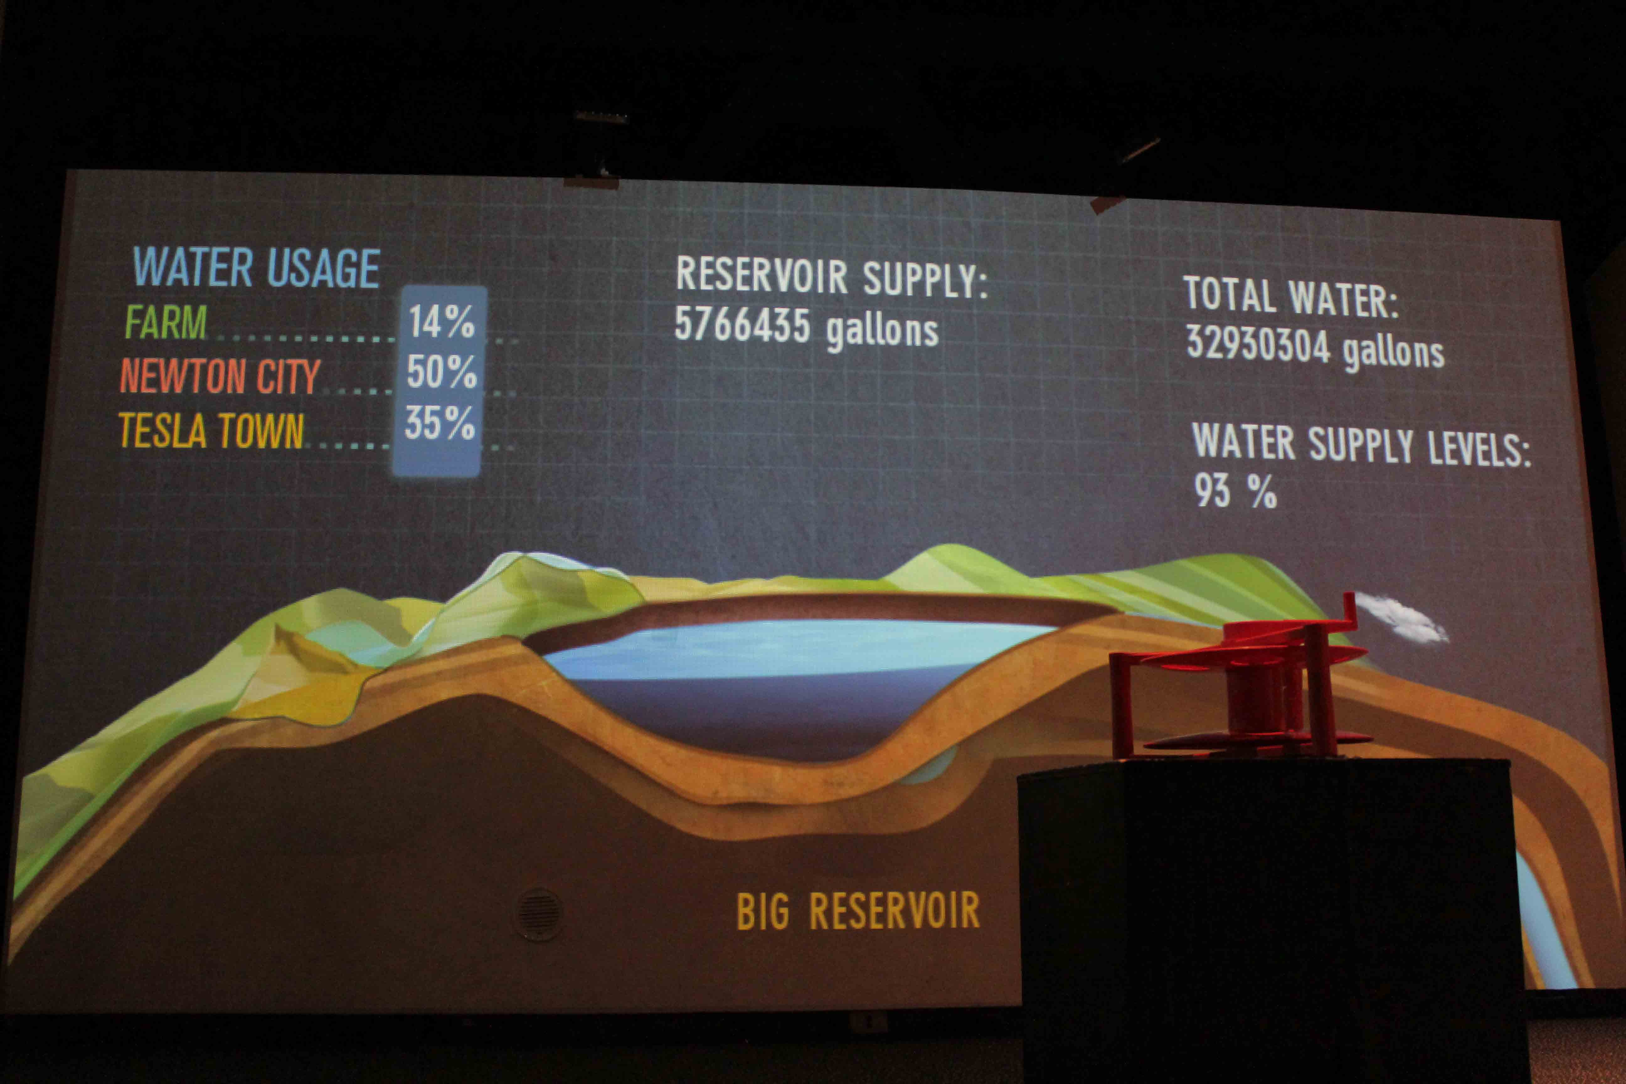
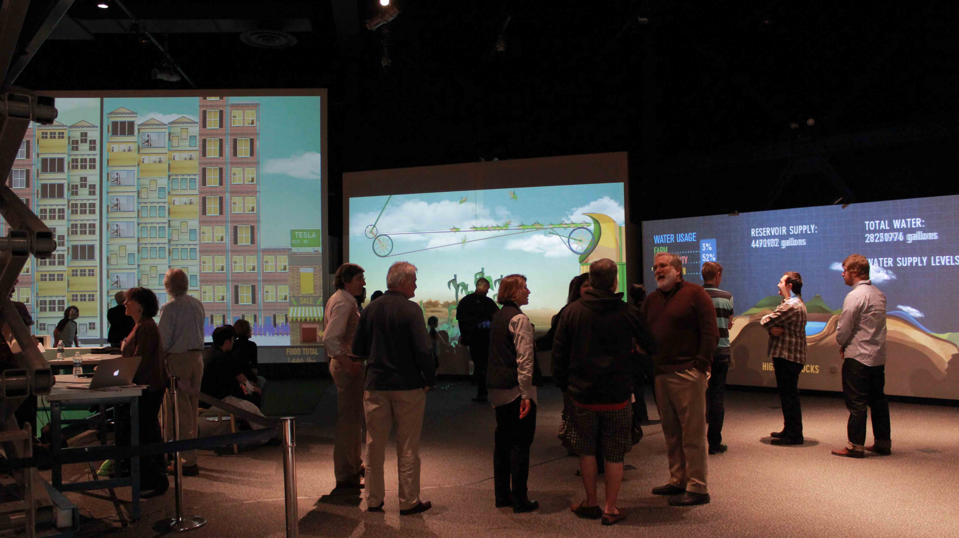

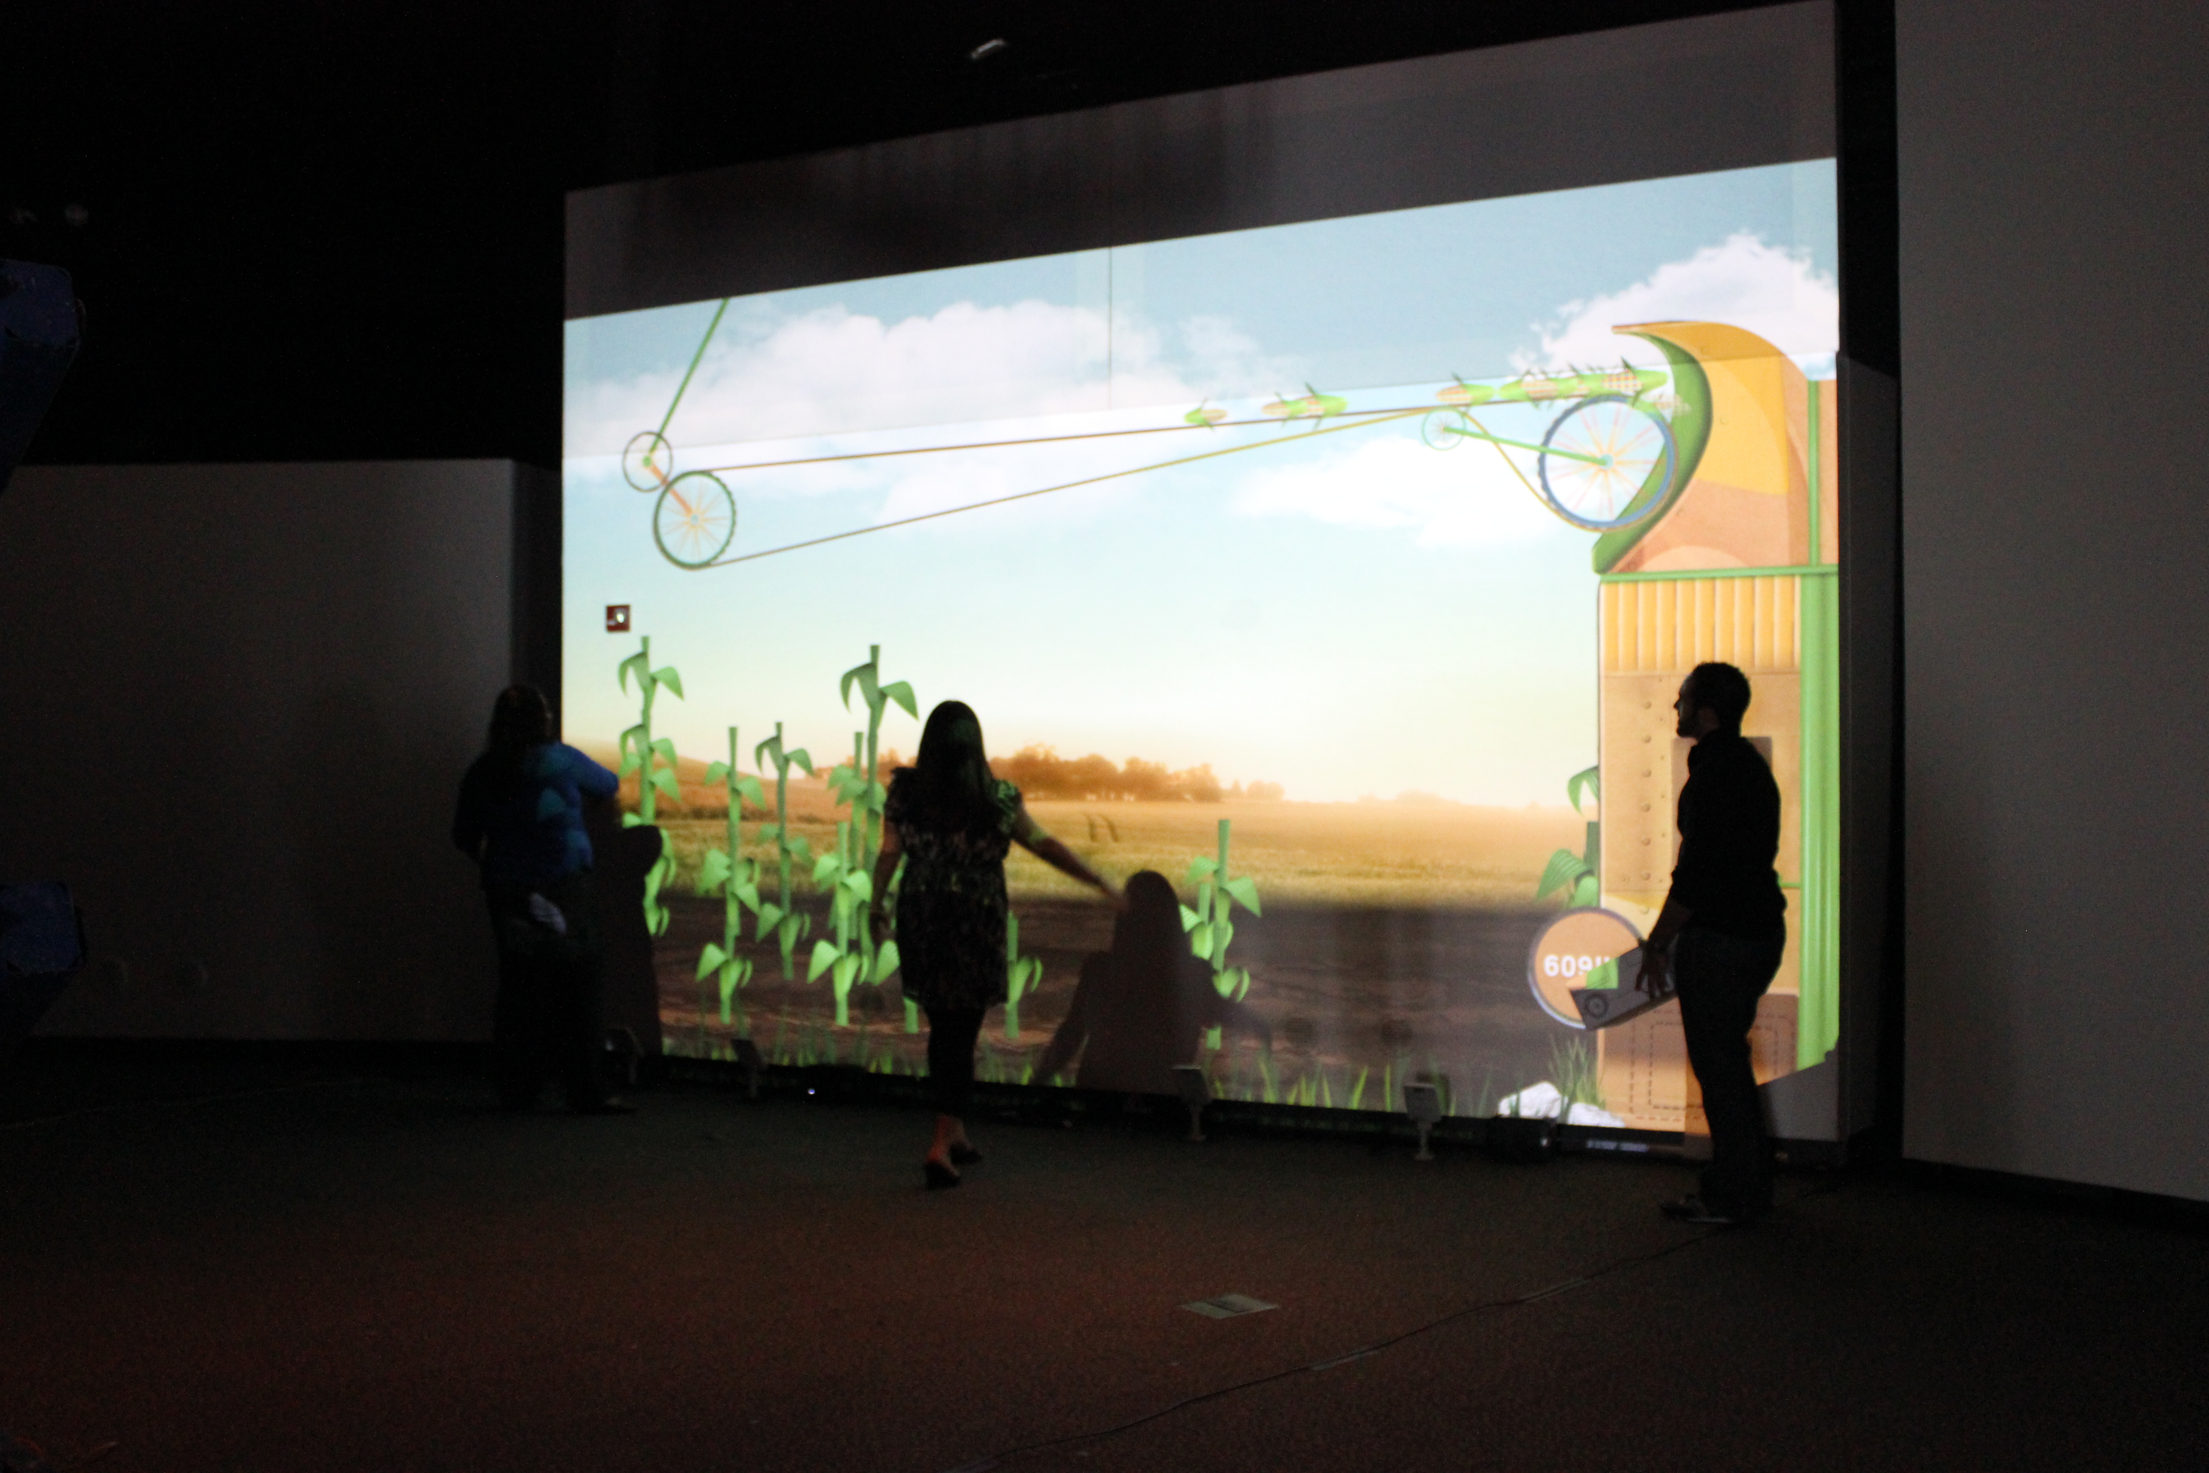

Our first prototypes included a city, farm and reservoirs. Visitors were challenged to distribute the water from a number of reservoirs between the needs of the farm and the city. They also had to ensure that enough food was produced on the farm to support the city.

The realistic environments invoked knee jerk reactions to the experience – visitors focused on ‘need to save water’ messages, and never got to the deeper ideas behind systems thinking and sustainability science.

After extensive testing, we chose to go with a more fantastical environment, where visitors would need to figure out how the world worked.

During development, we ran several months of prototypes that informed the nature of the interactions. After installation, we continued prototyping as we developed the facilitation techniques for both the casual family visitor and scheduled classes. Challenges are presented for the visitor that require systems thinking and STEM skills to succeed.

Testing

After a redesign of the environments and rethinking of the interactive elements, e embarked on prototype testing during the exhibition development during 2013-2014. Because of the scope for the exhibition, we were only able to test 2-3 projected environments at a time and never work with the projected floor. Results from the tests directed the development of the design and content for the exhibition. We worked with the Games for Learning Institute at NYU, led by Jan Plasse and NYSCI’s Design-Based Research team lead by Cornelia Brunner.

The exhibition opened in June of 2015. It was the first time we were able to see the exhibition will all the environments projected with the floor in play. The summer was spent testing facilitation for both group challenged (school groups) and family visitors. These tests were done by the Connected Worlds development team and NYSCI’s Design-Based Research team. We developed the following formats for the group games. Connected Worlds is a very deep and layered experience. So se continue to observe and interview visitors in the space and adjust the experience for different audience needs and focus.

Connected Worlds School Field Visits

Six immersive, imaginary environments, a towering waterfall and a flood plain make up Connected Worlds, an exhibit about sustainability and interconnectedness within ecosystems. Students transform these ecosystems as they discover, through exploration of the connections within and among the environments of a plains, desert, jungle, wetlands, river valley and reservoir. The goal of the experience is to encourage systems thinking to help see how a change made in one environment has an effect everywhere else. As students move water to develop one habitat, for instance to feed massive trees in the jungle’s canopy, other environments may decline due to the lack of available water. Creatures in those environments, who rely on certain plants retreat when the habitat is in decline.

Through facilitated, structured sessions, students will be invited to be explorers of this imaginary world to discern who can thrive and survive there. Teams are challenged to discover how animals and plants depend on each other and their habitats to survive and how changes in one part of the environment impact the stability of the entire system.

At each of the grade levels, teams will be presented with the challenge of sustaining life in the environment. Teams will explore different ways to balance their immediate and ongoing needs with those of other teams working to sustain their individual habitats. Facilitators will lead discussions around systems thinking, sustainability and environmental issues.

Facilitated session: 45 minutes

K-2: Who lives here? Plant and Animal Diversity

Students will identify our imaginary creatures and plants in their habitats and what they need to survive and thrive. They will observe patterns of when and why creatures emerge or leave a habitat and use strategies to sustain creatures in their particular environments. Special attention will be paid to plant and animal relationships to each other and their dependence on their environment.

Learning goals: Cause and effect reasoning, pattern thinking, plant and animal diversity; ecosystems.

3rd-4th: Engineering the World: Plant and Animal Adaptations

Changes in the environment start with water- where it is and where it needs to go to sustain life. Students will collaborate to create strategies for distributing water based on what they discover about the plants and creatures living there. Students will focus on the relationship of plants and animals to the health and balance of the overall ecosystem.

Learning goals: Plant and animal adaptations, animals and plants and their environments, interconnectedness, understanding systems as a set of components, engineering

5th-9th: Keeping Balance in a Changing World: Environmental Interdependence

Students explore what happens across these imaginary habitats under different environmental conditions. Working in teams, they create strategies to manage extreme conditions such as drought through water management and distribution. They will experience dynamic equilibrium while they work to maintain balance among environments that are in flux. Students investigate stability and change throughout the system by discovering how small changes in one area can have huge effects elsewhere on the plant and animal life. Their challenge is too keep all 4 habitats in balance – having a diversity of plants and animals and enough water to maintain them.

Learning goals: Interdependence; stability and change in ecosystems, dynamic equilibrium, systems thinking, engineering

